Name_________________ Group 3 Examples

_____1. What is the simplest form of $\frac{\sqrt{48x^{3}}}{\sqrt{36xy^{4}}}$?

1. $\frac{2x\sqrt{12}}{\sqrt{6y^{2}}}$ (3) $\frac{4x\sqrt{3}}{6y^{2}}$
2. $\frac{ 2x}{y^{2}}$ (4) $\frac{2x\sqrt{3}}{3y^{2}}$

_____2. What is the simplest form of: $\left(4-\sqrt{2} \right)\left(5+\sqrt{2} \right)?$

$18$

$18-\sqrt{2}$

$24$

$22+\sqrt{2}$

_____3. Simplify: ${(-216)}^{\frac{1}{3}}$ This is the same thing as $\sqrt[3]{-216}$



$6$

$-6$

$6i$

$-6i$

_____4. Solve for $x: \sqrt{10-3x}=4-x$



$2 only$

$5 only$

$2 and 3$

$1 and 5$

_____5. Simplify completely: $12\sqrt{32}-6\sqrt{50}$



$6\sqrt{-18}$

$6i\sqrt{18}-30\sqrt{2}$

$24\sqrt{8 }-30\sqrt{2}$

$18\sqrt{2}$

_____6. What is the simplified form of the expression $\sqrt{27x^{4}y^{7}}$, if 𝑥 and 𝑦 are positive?

(1) $9x^{4}y^{6}\sqrt{3y}$

(2) $9x^{2}y^{3}\sqrt{3y}$

(3) $3x^{2}y^{3}\sqrt{3y}$

(4) $3x^{4}y^{6}\sqrt{3y}$

_____7. How is the graph of $y=\sqrt{x}+23$ translated from the graph $=\sqrt{x}$?

(1) Shifted 23 units left

(2) Shifted 23 units right

(3) Shifted 23 units up

(4) Shifted 23 units down

8. Determine the transformations that were used to change the graph of the parent function $y=x^{3}$ to the graph shown below. State the equation of the graph shown below.

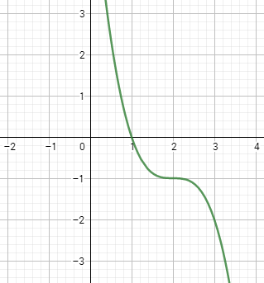

9. Solve for all possible values of x

$$3\sqrt[3]{x-3}+2=8$$